# How to Make a Bug Report

**# Source**: **Chatgpt (GPT-5-Standard) at [9/18/2025]**

A **bug report** is a document or message that describes a **problem (bug)** found in software — such as an app, website, or system — so that developers can understand it, reproduce it, and fix it. 🐞

## 💡 Simple Definition

**# Source**: **Chatgpt (GPT-5-Standard) at [9/18/2025]**

A **bug report** is a **record of an error or unexpected behavior** in a program.

It explains:

* **What went wrong**
* **How to make it happen again**
* **What should have happened instead**

## 🧠 Purpose

**# Source**: **Chatgpt (GPT-5-Standard) at [9/18/2025]**

The goal of a bug report is to **help developers fix the issue efficiently**.  
A clear bug report saves time and prevents confusion by giving all necessary details in one place.

## 🧩 Why Bug Reports Are Important

**# Source**: **Chatgpt (GPT-5-Standard) at [9/18/2025]**

* They **document** software problems.
* They help **developers reproduce** and **fix** bugs.
* They allow **testers and teams** to **track progress** on what’s fixed or pending.
* They ensure **quality control** before release.

## 🧾 Full Bug Report Structure (with all fields)

**# Source**: **Chatgpt (GPT-5-Standard) at [9/18/2025]**

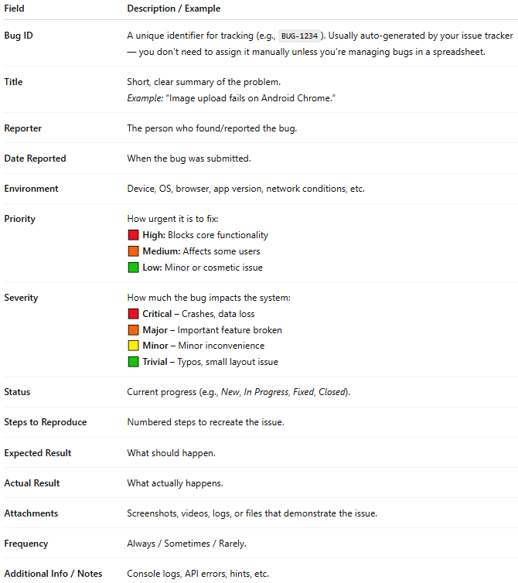

| **Field** | **Description / Example** |
| --- | --- |
| **Bug ID** | A unique identifier for tracking (e.g., BUG-1234). Usually auto-generated by your issue tracker — you don’t need to assign it manually unless you’re managing bugs in a spreadsheet. |
| **Title** | Short, clear summary of the problem.*Example:* “Image upload fails on Android Chrome.” |
| **Reporter** | The person who found/reported the bug. |
| **Date Reported** | When the bug was submitted. |
| **Environment** | Device, OS, browser, app version, network conditions, etc. |
| **Priority** | How urgent it is to fix:🟥 **High:** Blocks core functionality🟧 **Medium:** Affects some users🟩 **Low:** Minor or cosmetic issue |
| **Severity** | How much the bug impacts the system:🟥 **Critical** – Crashes, data loss🟧 **Major** – Important feature broken🟨 **Minor** – Minor inconvenience🟩 **Trivial** – Typos, small layout issue |
| **Status** | Current progress (e.g., *New*, *In Progress*, *Fixed*, *Closed*). |
| **Steps to Reproduce** | Numbered steps to recreate the issue. |
| **Expected Result** | What should happen. |
| **Actual Result** | What actually happens. |
| **Attachments** | Screenshots, videos, logs, or files that demonstrate the issue. |
| **Frequency** | Always / Sometimes / Rarely. |
| **Additional Info / Notes** | Console logs, API errors, hints, etc. |

## Priority and Severity

### what is Priority

**# Source**: **Chatgpt (GPT-5-Standard) at [9/18/2025]**

In a **bug report**, **Priority** means **how urgently the bug should be fixed**.  
It helps developers and project managers decide **which issues to work on first**.

#### ⚙️ Definition

**# Source**: **Chatgpt (GPT-5-Standard) at [9/18/2025]**

**Priority** = *The order in which a bug should be fixed, based on business or project needs.*

It answers:

“How soon does this need to be fixed?”

#### 🧭 Common Priority Levels

**# Source**: **Chatgpt (GPT-5-Standard) at [9/18/2025]**

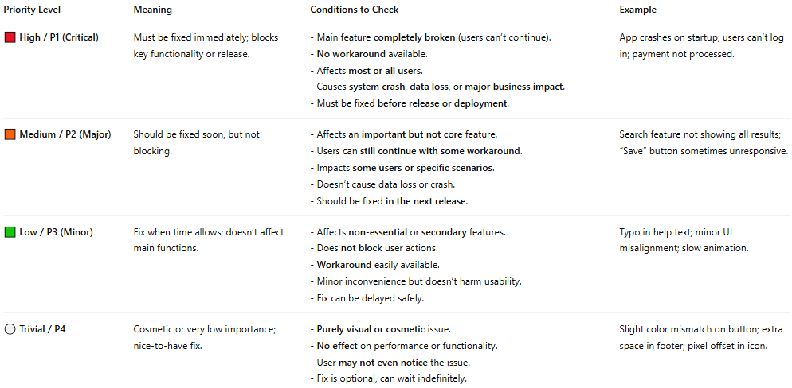

| **Priority Level** | **Meaning** | **Conditions to Check** | **Example** |
| --- | --- | --- | --- |
| **🟥 High / P1 (Critical)** | **Must be fixed immediately; blocks key functionality or release.** | **- Main feature completely broken (users can’t continue).- No workaround available.- Affects most or all users.- Causes system crash, data loss, or major business impact.- Must be fixed before release or deployment.** | **App crashes on startup; users can’t log in; payment not processed.** |
| **🟧 Medium / P2 (Major)** | **Should be fixed soon, but not blocking.** | **- Affects an important but not core feature.- Users can still continue with some workaround.- Impacts some users or specific scenarios.- Doesn’t cause data loss or crash.- Should be fixed in the next release.** | **Search feature not showing all results; “Save” button sometimes unresponsive.** |
| **🟩 Low / P3 (Minor)** | **Fix when time allows; doesn’t affect main functions.** | **- Affects non-essential or secondary features.- Does not block user actions.- Workaround easily available.- Minor inconvenience but doesn’t harm usability.- Fix can be delayed safely.** | **Typo in help text; minor UI misalignment; slow animation.** |
| **⚪ Trivial / P4** | **Cosmetic or very low importance; nice-to-have fix.** | **- Purely visual or cosmetic issue.- No effect on performance or functionality.- User may not even notice the issue.- Fix is optional, can wait indefinitely.** | **Slight color mismatch on button; extra space in footer; pixel offset in icon.** |

**⚙️ Quick Decision Checklist**

**When you find a bug, ask yourself:**

1. **❌ Does it block the user from completing key actions?  
   → Yes → High Priority**
2. **⚠️ Does it affect important but not critical functionality?  
   → Yes → Medium Priority**
3. **💬 Is it just a small inconvenience or minor display issue?  
   → Yes → Low Priority**
4. **🖋️ Is it purely cosmetic (like spelling, spacing, or color)?  
   → Yes → Trivial Priority**

### what is Severity

#### ⚙️ Definition

**# Source**: **Chatgpt (GPT-5-Standard) at [9/18/2025]**

**Severity** means **how serious the bug’s impact is on the system or user experience.**  
It describes **how badly the bug breaks things** — not how fast it needs to be fixed (that’s *Priority*).

It answers:

“How bad is the problem?”

#### 🧭 Common Severity Levels

**# Source**: **Chatgpt (GPT-5-Standard) at [9/18/2025]**

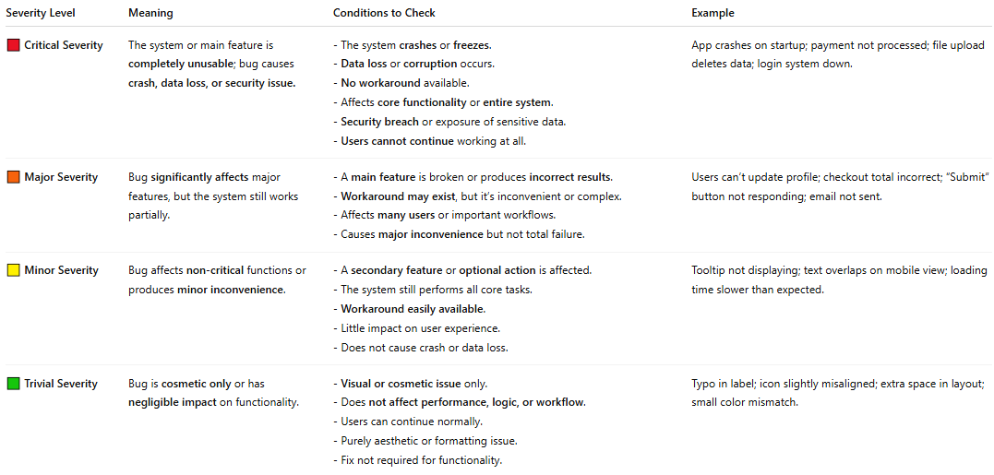

| **Severity Level** | **Meaning** | **Conditions to Check** | **Example** |
| --- | --- | --- | --- |
| **🟥 Critical Severity** | **The system or main feature is completely unusable; bug causes crash, data loss, or security issue.** | **- The system crashes or freezes.- Data loss or corruption occurs.- No workaround available.- Affects core functionality or entire system.- Security breach or exposure of sensitive data.- Users cannot continue working at all.** | **App crashes on startup; payment not processed; file upload deletes data; login system down.** |
| **🟧 Major Severity** | **Bug significantly affects major features, but the system still works partially.** | **- A main feature is broken or produces incorrect results.- Workaround may exist, but it’s inconvenient or complex.- Affects many users or important workflows.- Causes major inconvenience but not total failure.** | **Users can’t update profile; checkout total incorrect; “Submit” button not responding; email not sent.** |
| **🟨 Minor Severity** | **Bug affects non-critical functions or produces minor inconvenience.** | **- A secondary feature or optional action is affected.- The system still performs all core tasks.- Workaround easily available.- Little impact on user experience.- Does not cause crash or data loss.** | **Tooltip not displaying; text overlaps on mobile view; loading time slower than expected.** |
| **🟩 Trivial Severity** | **Bug is cosmetic only or has negligible impact on functionality.** | **- Visual or cosmetic issue only.- Does not affect performance, logic, or workflow.- Users can continue normally.- Purely aesthetic or formatting issue.- Fix not required for functionality.** | **Typo in label; icon slightly misaligned; extra space in layout; small color mismatch.** |

**⚙️ Quick Decision Checklist**

Ask yourself these questions when determining severity:

1. ❌ Does it **crash** the system or cause **data loss**?  
   → **Yes → Critical**
2. ⚠️ Does it **break a main feature** but allow partial use or workaround?  
   → **Yes → Major**
3. 💬 Does it cause **minor inconvenience** without blocking work?  
   → **Yes → Minor**
4. 🖋️ Is it just **visual or cosmetic** with no functional impact?  
   → **Yes → Trivial**

#### 💡 Key Difference Between Severity and Priority

**# Source**: **Chatgpt (GPT-5-Standard) at [9/18/2025]**

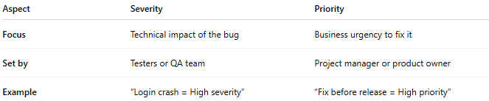

| **Aspect** | **Severity** | **Priority** |
| --- | --- | --- |
| **Focus** | Technical impact of the bug | Business urgency to fix it |
| **Set by** | Testers or QA team | Project manager or product owner |
| **Example** | “Login crash = High severity” | “Fix before release = High priority” |

#### 🧠 Example:

**# Source**: **Chatgpt (GPT-5-Standard) at [9/18/2025]**

If the **company logo is misspelled**,

* **Severity:** Low (doesn’t break functionality)
* **Priority:** High (bad for brand image — must fix before release)

### 🧠 Tip:

**# Source**: **Chatgpt (GPT-5-Standard) at [9/18/2025]**

* **Priority** = Business importance (how soon to fix)
* **Severity** = Technical impact (how bad the bug is)

They’re related, but **not the same**.

Example: A typo in the app name → **Low severity**, but maybe **High priority** before launch!

### 🧩 Examples Showing the Difference Between Severity and Priority

**# Source**: **Chatgpt (GPT-5-Standard) at [9/18/2025]**

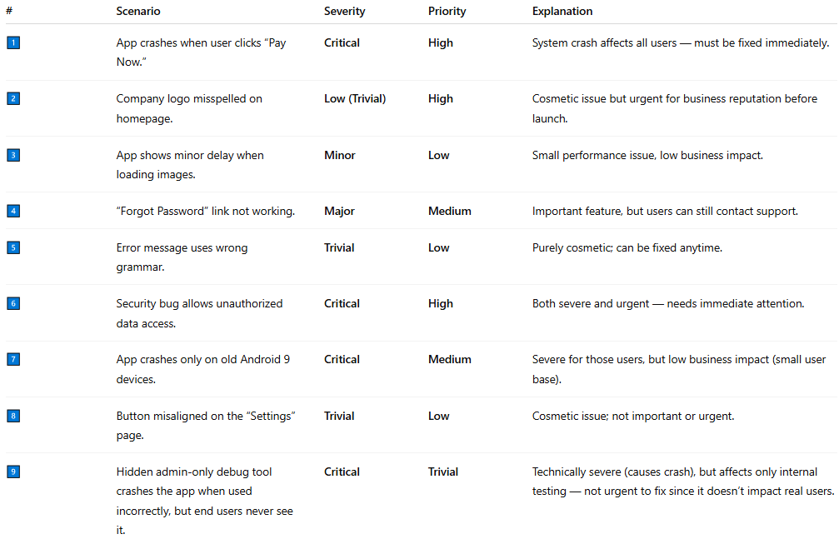

| **#** | **Scenario** | **Severity** | **Priority** | **Explanation** |
| --- | --- | --- | --- | --- |
| 1️⃣ | App crashes when user clicks “Pay Now.” | **Critical** | **High** | System crash affects all users — must be fixed immediately. |
| 2️⃣ | Company logo misspelled on homepage. | **Low (Trivial)** | **High** | Cosmetic issue but urgent for business reputation before launch. |
| 3️⃣ | App shows minor delay when loading images. | **Minor** | **Low** | Small performance issue, low business impact. |
| 4️⃣ | “Forgot Password” link not working. | **Major** | **Medium** | Important feature, but users can still contact support. |
| 5️⃣ | Error message uses wrong grammar. | **Trivial** | **Low** | Purely cosmetic; can be fixed anytime. |
| 6️⃣ | Security bug allows unauthorized data access. | **Critical** | **High** | Both severe and urgent — needs immediate attention. |
| 7️⃣ | App crashes only on old Android 9 devices. | **Critical** | **Medium** | Severe for those users, but low business impact (small user base). |
| 8️⃣ | Button misaligned on the “Settings” page. | **Trivial** | **Low** | Cosmetic issue; not important or urgent. |
| 9️⃣ | Hidden admin-only debug tool crashes the app when used incorrectly, but end users never see it. | **Critical** | **Trivial** | Technically severe (causes crash), but affects only internal testing — not urgent to fix since it doesn’t impact real users. |

## Procedure Steps for Writing a Complete Bug Report

**# Source**: **Chatgpt (GPT-5-Standard) at [9/18/2025]**

**🧩 Step 1: Identify and Confirm the Bug**

* Verify that the issue is **repeatable** and **not caused by user error or environment setup.**
* Try to **reproduce it at least twice** before reporting.
* Note the exact conditions under which it occurs (device, OS, version, etc.).

**🧩 Step 2: Gather Environment Details**

Record the environment where the bug occurred:

* Device / OS (e.g., Windows 11, Android 14)
* Browser / App Version (e.g., Chrome 128.0)
* Network type (Wi-Fi, 4G, offline, etc.)
* Build version or test environment (e.g., “Staging v2.3.5”)

**🧩 Step 3: Write a Clear and Descriptive Title**

* Keep it short but specific — it should **summarize the problem at a glance.**  
  ✅ *Example:* “Login button unresponsive on mobile Safari.”

**🧩 Step 4: Assign Basic Fields**

Fill in standard bug fields (if using a tracker like Jira, Trello, or Excel):

* **Bug ID:** (auto-generated or manually assigned)
* **Reporter:** (your name)
* **Date Reported:** (current date)
* **Status:** New / Open / In Progress / Closed
* **Priority:** Decide urgency (High, Medium, Low, Trivial)
* **Severity:** Decide impact (Critical, Major, Minor, Trivial)

Use your **Priority and Severity condition tables** to determine the correct levels.

**🧩 Step 5: Provide Detailed Steps to Reproduce**

Describe **exact steps** to reproduce the issue, one per line:

1. Open the app or webpage.
2. Go to the “Login” screen.
3. Enter valid credentials.
4. Tap “Login.”

💡 *Tip:* The developer should be able to reproduce the issue **just by following your steps**.

**🧩 Step 6: Describe the Expected and Actual Results**

* **Expected Result:** What should happen normally.
* **Actual Result:** What actually happens when the bug occurs.

✅ *Example:*

* Expected: “User is redirected to dashboard after login.”
* Actual: “Login button turns grey and does nothing.”

**🧩 Step 7: Add Frequency**

Specify how often it happens:

* **Always** (100%)
* **Sometimes** (intermittent)
* **Rarely**

**🧩 Step 8: Attach Evidence**

Include:

* **Screenshots** (to show UI or error messages)
* **Videos** (to demonstrate steps)
* **Logs or Console Errors** (to help developers trace the cause)

📎 *Example:* Attach login_error.mp4 and console_log.txt.

**🧩 Step 9: Add Additional Information**

* API error codes
* Database or system logs
* Related issues or dependencies
* Workarounds (if available)

**🧩 Step 10: Review Before Submission**

✅ Check that:

* The **title is clear** and specific.
* **Steps to reproduce** are complete.
* **Expected/Actual results** are correctly described.
* **Attachments** are included and relevant.
* **Priority and Severity** are correctly assigned.

Then submit it in your **bug tracking system** (e.g., Jira, GitHub, ClickUp, Excel, etc.).

## 🧱 Complete Bug Report Example

**# Source**: **Chatgpt (GPT-5-Standard) at [9/18/2025]**

**Bug ID:** BUG-2025-014  
**Title:** Image upload fails on Android Chrome  
**Reporter:** Jane Doe  
**Date Reported:** 2025-10-06  
**Environment:**

* Device: Samsung Galaxy S23
* OS: Android 14
* Browser: Chrome 128
* App Version: v2.4.1
* Network: Wi-Fi

**Priority:** High  
**Severity:** Major  
**Status:** New

**Steps to Reproduce:**

1. Go to “Profile” page.
2. Tap “Change Profile Picture.”
3. Select an image from gallery.
4. Tap “Upload.”

**Expected Result:**  
Image uploads and displays successfully.

**Actual Result:**  
Spinner loads indefinitely; image never appears.

**Frequency:** Always

**Attachments:**

* upload_error.mp4
* console_log.txt

**Additional Info:**  
Console shows POST 500 error.  
Workaround: None.